Artificial intelligence in 10 years
So, what really is Artificial intelligence that seems to be the next best thing? It is not the next best thing; IT IS the new best thing as it lives and used nearly everywhere! 2022 was the year when Artificial intelligence really broke into the public eye with the release of the chatbot ChatGPT. This was a significant factor to the hype and buzz around AI as we know it.
AI does more than just the likes of ChatGPT with it playing significant roles in nearly every industry today! Anthropic another highly known company providing ‘Clauda’ AI chatbot released as AI exposure index into what sort of impact this can make on all the occupational categories.
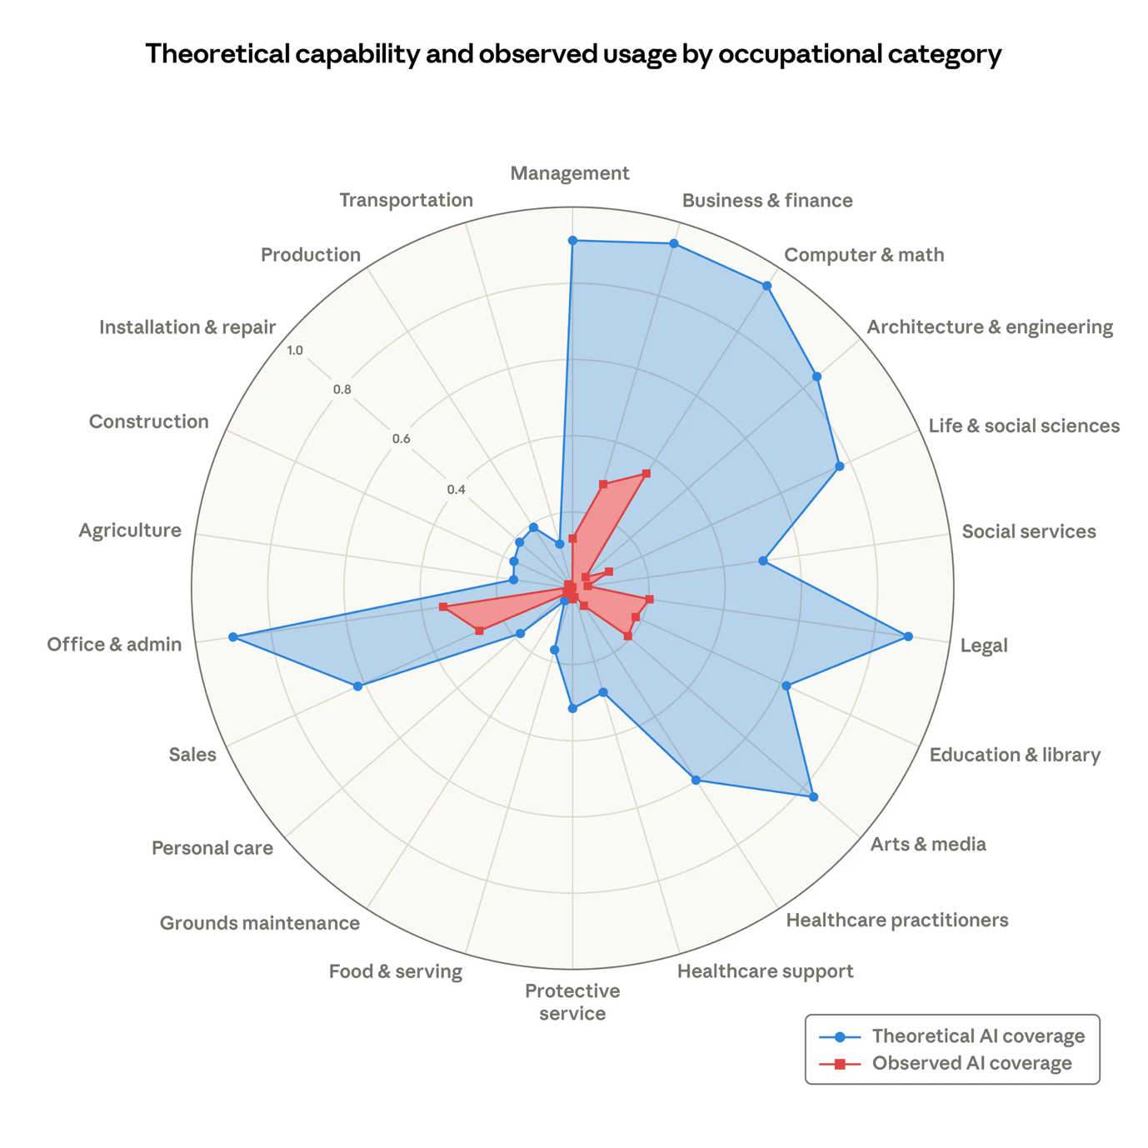
Figure 1: Theoretical capability and observed exposure by occupational category. (Massenkoff and McCrory, 2026)

As seen in the image above it shows quite a lot of industries are projected to feel the impact or benefits of A and the current exposure. Now although this may seem a lot, I believe AI will augment roles and technical roles will have to adapt and integrate AI as part of their assisting tools. For more entry-level roles some of these may be potentially automated due to their simplicity or repetitiveness’ but this will evolve or create new roles such AI safety and prompting.
Businesses could transition from solely human roles to hybrid roles, where employees use prompts or commands to assist with tasks and automate or quickly solve simple ones, freeing up time and energy for more complex tasks. This technological advancement has naturally led to fear or job disruption, either through automation of certain roles or forcing employees to develop new skill sets. However, the job market has faced minimal impact since the release of ChatGPT in 2022, with the main area being early-career high AI exposure jobs such as software engineers.
The rapid growth of AI brings significant security challenges, particularly data privacy concerns. The vast amounts of data required for training AI models, which may include personal information, raise public fears of data misuse and potential biases leading to discriminatory outcomes. To address these issues, techniques like feature and bias preprocessing, as well as training on artificially generated data that mimics real-world patterns, are employed to mitigate risks and ensure ethical AI development (Thomas, 2026).
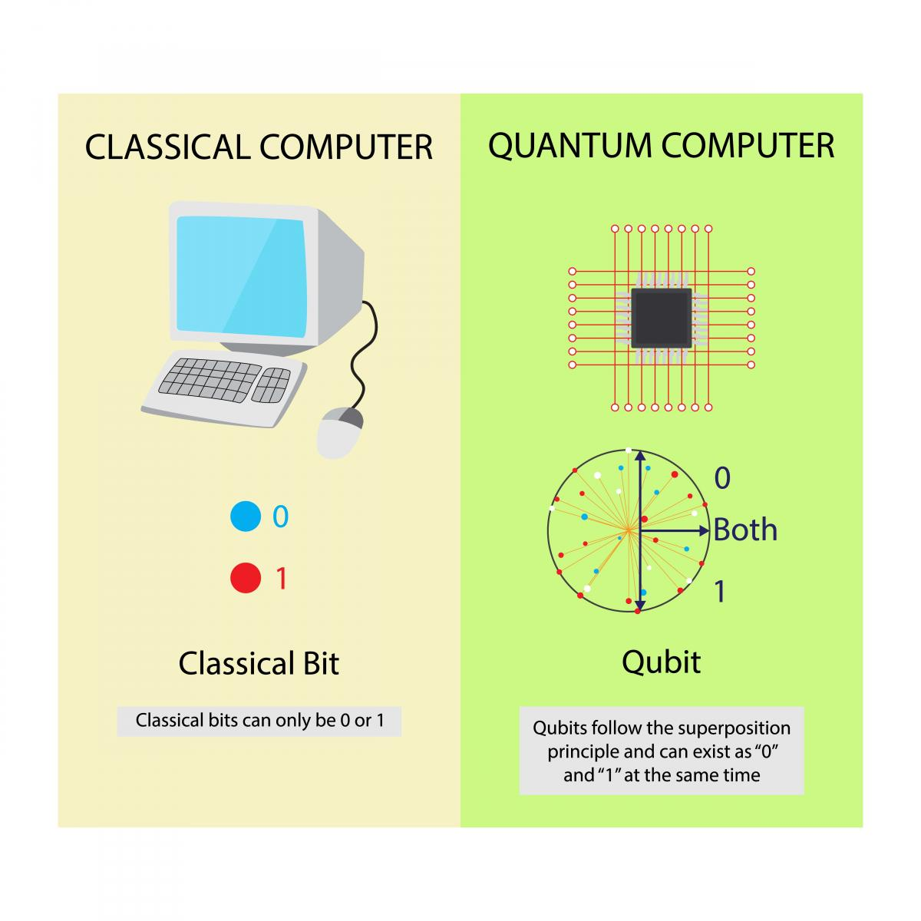
Figure 2: Quantum computing binary usage.

Lead companies in AI are already looking to challenge it growth rate with things such as quantum AI which has the potential to shatter limitations of normal AI (Mucci, 2024). Quantum computing is far from solved yet but it with the vast amount of data and computing power needed for current AI models, quantum computing Is set to break these current limits.
While AI may seem scary and some people thinking the Terminator series coming into real life within exponential advancements. AI can only grow with as fast as societal adoption meaning some jobs might be automated but with skill uplifting and new or augmented jobs AI could unlock valuable time and energy for people in the future.

Anthropic. (2026) Labor market impacts of AI: A new measure and early evidence. Available at: https://www.anthropic.com/research/labor-market-impacts (Accessed: 08/03/2026)
Mucci, T. (2024) The future of AI: trends shaping the next 10 years. Available at: https://www.ibm.com/think/insights/artificial-intelligence-future (Accessed: 08/03/2026)
Thomas, M. (2026) The future of AI: How Artificial Intelligence Will change the world. Available at: https://builtin.com/artificial-intelligence/artificial-intelligence-future (Accessed: 08/03/2026)

